**Critical Thinking Group 4: DATA621 Homework 5**

Table of Contents

TEAM Members: 3

Training Dataset 5

Evaluation Dataset 6

Missing Values & Data Type Check 7

Data Statistics Summary 9

Outliers 11

Histogram of attributes 11

Density Plot 19

Label Scores 20

Univariate Analysis 20

Response Variable 20

Correlation Plot 21

The correlation matrix below shows that the response variable TARGET has strong positive relationship (>=0.6) with variables FixedAcidity,CitricAcid,ResidualSugar,Density,Alcohol. 22

Scatter plots against TARGET: 23

There don’t seem to be any crazy patterns here. It mostly looks linear which is a good sign for us. STARS and LableAppleal look like they have the greatest correlation. 24

Consolidated Data Dictionary 25

DATA PREPARATION 25

BUILD MODELS 26

Model I: Poisson Model 26

Model 1: Poisson Model without imputations 26

Model 2: Poisson Model without imputations and only significant variables 30

Model 3: Poisson Model with imputations 34

Model 4: Poisson Model with imputations and only significant variables 38

Model II: Negative Binomial 41

Model 5 : Negative Binomial without imputations 41

Model 6 : Negative Binomial without imputations and only significant variables 44

Model 7 : Negative Binomial with imputations 47

Model 8 : Negative Binomial with imputations and only significant variables 51

Model III: Linear Model 54

Model 9 : Linear Model with imputations 54

Model 10 : Linear Model with imputations and only significant variables. 58

Model 11 : Ordinal Logistic Regression 62

Model 12 : Zero inflation 63

MODEL SELECTION 65

Compare Models by MSE/AIC 65

6.3 Prediction on Evaluation Data 67

## TEAM Members:

Rajwant Mishra  
Priya Shaji  
Debabrata Kabiraj  
Isabel Ramesar  
Sin Ying Wong  
Fan Xu

-------------------------------------------------

**Overview**

In this homework assignment, you will explore, analyze and model a data set containing information on approximately 12,000 commercially available wines. The variables are mostly related to the chemical properties of the wine being sold. The response variable is the number of sample cases of wine that were purchased by wine distribution companies after sampling a wine. These cases would be used to provide tasting samples to restaurants and wine stores around the United States. The more sample cases purchased, the more likely is a wine to be sold at a high end restaurant. A large wine manufacturer is studying the data in order to predict the number of wine cases ordered based upon the wine characteristics. If the wine manufacturer can predict the number of cases, then that manufacturer will be able to adjust their wine offering to maximize sales.

Your objective is to build a count regression model to predict the number of cases of wine that will be sold given certain properties of the wine. HINT: Sometimes, the fact that a variable is missing is actually predictive of the target. You can only use the variables given to you (or variables that you derive from the variables provided).

Below is a short description of the variables of interest in the data set:

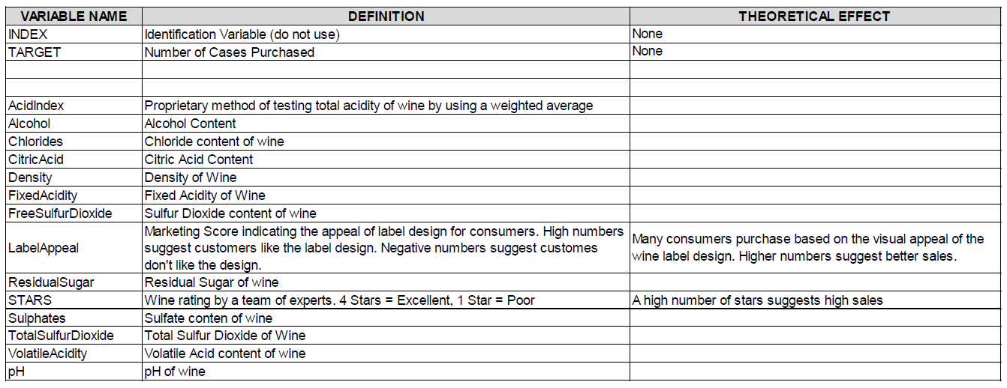

**Deliverables**

A write-up of your solutions submitted in PDF format.

Assigned predictions (number of cases of wine sold) for the evaluation data set.

**Data Load**

We have two datasets.

* One is the wine training dataset, which includes 14 candidate predictors, 1 response variable and 12795 observations.
* Other one is the wine evaluation dataset, which also includes 14 candidate predictors, 1 response variable but 16129 observations.

We are going to study their missing values, data types and data statistics.

### Training Dataset

|  | **TARGET** | **INDEX** | **FixedAcidity** | **VolatileAcidity** | **CitricAcid** | **ResidualSugar** | **Chlorides** | **FreeSulfurDioxide** | **TotalSulfurDioxide** | **Density** | **pH** | **Sulphates** | **Alcohol** | **LabelAppeal** | **AcidIndex** | **STARS** |
| --- | --- | --- | --- | --- | --- | --- | --- | --- | --- | --- | --- | --- | --- | --- | --- | --- |
| 1 | 3 | 1 | 3.2 | 1.16 | -0.98 | 54.2 | -0.567 |  | 268 | 0.9928 | 3.33 | -0.59 | 9.9 | 0 | 8 | 2 |
| 2 | 3 | 2 | 4.5 | 0.16 | -0.81 | 26.1 | -0.425 | 15 | -327 | 1.02792 | 3.38 | 0.7 |  | -1 | 7 | 3 |
| 3 | 5 | 4 | 7.1 | 2.64 | -0.88 | 14.8 | 0.037 | 214 | 142 | 0.99518 | 3.12 | 0.48 | 22 | -1 | 8 | 3 |
| 4 | 3 | 5 | 5.7 | 0.385 | 0.04 | 18.8 | -0.425 | 22 | 115 | 0.9964 | 2.24 | 1.83 | 6.2 | -1 | 6 | 1 |
| 5 | 4 | 6 | 8 | 0.33 | -1.26 | 9.4 |  | -167 | 108 | 0.99457 | 3.12 | 1.77 | 13.7 | 0 | 9 | 2 |
| 6 | 0 | 7 | 11.3 | 0.32 | 0.59 | 2.2 | 0.556 | -37 | 15 | 0.9994 | 3.2 | 1.29 | 15.4 | 0 | 11 |  |
| 7 | 0 | 8 | 7.7 | 0.29 | -0.4 | 21.5 | 0.06 | 287 | 156 | 0.99572 | 3.49 | 1.21 | 10.3 | 0 | 8 |  |
| 8 | 4 | 11 | 6.5 | -1.22 | 0.34 | 1.4 | 0.04 | 523 | 551 | 1.03236 | 3.2 |  | 11.6 | 1 | 7 | 3 |
| 9 | 3 | 12 | 14.8 | 0.27 | 1.05 | 11.25 | -0.007 | -213 |  | 0.9962 | 4.93 | 0.26 | 15 | 0 | 6 |  |
| 10 | 6 | 13 | 5.5 | -0.22 | 0.39 | 1.8 | -0.277 | 62 | 180 | 0.94724 | 3.09 | 0.75 | 12.6 | 0 | 8 | 4 |

Showing 1 to 10 of 12,795 entries

## Observations: 12,795

## Variables: 16

## $ TARGET <dbl> 3, 3, 5, 3, 4, 0, 0, 4, 3, 6, 0, 4, 3, 7, 4, 0, ...

## $ INDEX <dbl> 1, 2, 4, 5, 6, 7, 8, 11, 12, 13, 14, 15, 16, 17,...

## $ FixedAcidity <dbl> 3.2, 4.5, 7.1, 5.7, 8.0, 11.3, 7.7, 6.5, 14.8, 5...

## $ VolatileAcidity <dbl> 1.160, 0.160, 2.640, 0.385, 0.330, 0.320, 0.290,...

## $ CitricAcid <dbl> -0.98, -0.81, -0.88, 0.04, -1.26, 0.59, -0.40, 0...

## $ ResidualSugar <dbl> 54.20, 26.10, 14.80, 18.80, 9.40, 2.20, 21.50, 1...

## $ Chlorides <dbl> -0.567, -0.425, 0.037, -0.425, NA, 0.556, 0.060,...

## $ FreeSulfurDioxide <dbl> NA, 15, 214, 22, -167, -37, 287, 523, -213, 62, ...

## $ TotalSulfurDioxide <dbl> 268, -327, 142, 115, 108, 15, 156, 551, NA, 180,...

## $ Density <dbl> 0.99280, 1.02792, 0.99518, 0.99640, 0.99457, 0.9...

## $ pH <dbl> 3.33, 3.38, 3.12, 2.24, 3.12, 3.20, 3.49, 3.20, ...

## $ Sulphates <dbl> -0.59, 0.70, 0.48, 1.83, 1.77, 1.29, 1.21, NA, 0...

## $ Alcohol <dbl> 9.9, NA, 22.0, 6.2, 13.7, 15.4, 10.3, 11.6, 15.0...

## $ LabelAppeal <dbl> 0, -1, -1, -1, 0, 0, 0, 1, 0, 0, 1, 0, 1, 2, 0, ...

## $ AcidIndex <dbl> 8, 7, 8, 6, 9, 11, 8, 7, 6, 8, 5, 10, 7, 8, 9, 8...

## $ STARS <dbl> 2, 3, 3, 1, 2, NA, NA, 3, NA, 4, 1, 2, 2, 3, NA,...

### Evaluation Dataset

|  | **IN** | **TARGET** | **FixedAcidity** | **VolatileAcidity** | **CitricAcid** | **ResidualSugar** | **Chlorides** | **FreeSulfurDioxide** | **TotalSulfurDioxide** | **Density** | **pH** | **Sulphates** | **Alcohol** | **LabelAppeal** | **AcidIndex** | **STARS** |
| --- | --- | --- | --- | --- | --- | --- | --- | --- | --- | --- | --- | --- | --- | --- | --- | --- |
| 1 | 3 |  | 5.4 | -0.86 | 0.27 | -10.7 | 0.092 | 23 | 398 | 0.98527 | 5.02 | 0.64 | 12.3 | -1 | 6 |  |
| 2 | 9 |  | 12.4 | 0.385 | -0.76 | -19.7 | 1.169 | -37 | 68 | 0.99048 | 3.37 | 1.09 | 16 | 0 | 6 | 2 |
| 3 | 10 |  | 7.2 | 1.75 | 0.17 | -33 | 0.065 | 9 | 76 | 1.04641 | 4.61 | 0.68 | 8.55 | 0 | 8 | 1 |
| 4 | 18 |  | 6.2 | 0.1 | 1.8 | 1 | -0.179 | 104 | 89 | 0.98877 | 3.2 | 2.11 | 12.3 | -1 | 8 | 1 |
| 5 | 21 |  | 11.4 | 0.21 | 0.28 | 1.2 | 0.038 | 70 | 53 | 1.02899 | 2.54 | -0.07 | 4.8 | 0 | 10 |  |
| 6 | 30 |  | 17.6 | 0.04 | -1.15 | 1.4 | 0.535 | -250 | 140 | 0.95028 | 3.06 | -0.02 | 11.4 | 1 | 8 | 4 |
| 7 | 31 |  | 15.5 | 0.53 | -0.53 | 4.6 | 1.263 | 10 | 17 | 1.0002 | 3.07 | 0.75 | 8.5 | 0 | 12 | 3 |
| 8 | 37 |  | 15.9 | 1.19 | 1.14 | 31.9 | -0.299 | 115 | 381 | 1.03416 | 2.99 | 0.31 | 11.4 | 1 | 7 |  |
| 9 | 39 |  | 11.6 | 0.32 | 0.55 | -50.9 | 0.076 | 35 | 83 | 1.0002 | 3.32 | 2.18 | -0.5 | 0 | 12 |  |
| 10 | 47 |  | 3.8 | 0.22 | 0.31 | -7.7 | 0.039 | 40 | 129 | 0.9061 | 4.72 | -0.64 | 10.9 | 0 | 7 |  |

Showing 1 to 10 of 3,335 entries

## Observations: 3,335

## Variables: 16

## $ IN <dbl> 3, 9, 10, 18, 21, 30, 31, 37, 39, 47, 60, 62, 63...

## $ TARGET <lgl> NA, NA, NA, NA, NA, NA, NA, NA, NA, NA, NA, NA, ...

## $ FixedAcidity <dbl> 5.4, 12.4, 7.2, 6.2, 11.4, 17.6, 15.5, 15.9, 11....

## $ VolatileAcidity <dbl> -0.860, 0.385, 1.750, 0.100, 0.210, 0.040, 0.530...

## $ CitricAcid <dbl> 0.27, -0.76, 0.17, 1.80, 0.28, -1.15, -0.53, 1.1...

## $ ResidualSugar <dbl> -10.70, -19.70, -33.00, 1.00, 1.20, 1.40, 4.60, ...

## $ Chlorides <dbl> 0.092, 1.169, 0.065, -0.179, 0.038, 0.535, 1.263...

## $ FreeSulfurDioxide <dbl> 23, -37, 9, 104, 70, -250, 10, 115, 35, 40, NA, ...

## $ TotalSulfurDioxide <dbl> 398, 68, 76, 89, 53, 140, 17, 381, 83, 129, 583,...

## $ Density <dbl> 0.98527, 0.99048, 1.04641, 0.98877, 1.02899, 0.9...

## $ pH <dbl> 5.02, 3.37, 4.61, 3.20, 2.54, 3.06, 3.07, 2.99, ...

## $ Sulphates <dbl> 0.64, 1.09, 0.68, 2.11, -0.07, -0.02, 0.75, 0.31...

## $ Alcohol <dbl> 12.30, 16.00, 8.55, 12.30, 4.80, 11.40, 8.50, 11...

## $ LabelAppeal <dbl> -1, 0, 0, -1, 0, 1, 0, 1, 0, 0, 0, 1, 0, 0, -1, ...

## $ AcidIndex <dbl> 6, 6, 8, 8, 10, 8, 12, 7, 12, 7, 8, 10, 9, 8, 9,...

## $ STARS <dbl> NA, 2, 1, 1, NA, 4, 3, NA, NA, NA, 1, NA, 2, NA,...

### Missing Values & Data Type Check

In the wine training dataset, there are 14 candidate predictors and 1 response variable with 12,795 observations. In the wine evaluation dataset, there are 14 candidate predictors with 3,335 observations. Both datasets have no missing values (eg: NA, NULL or ’’).

Among the 12 candidate predictors, 3 are categorical (LabelAppeal,AcidIndex,STARS), the other 11 are continuous numerical. The response variable TARGET is categorical.

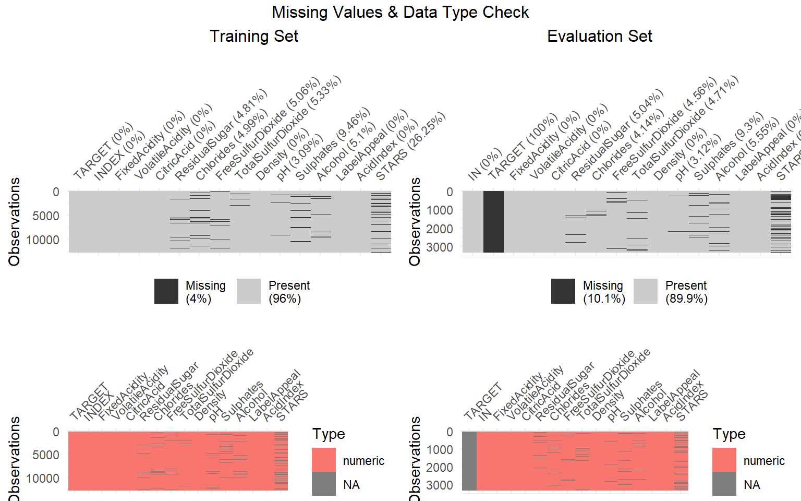

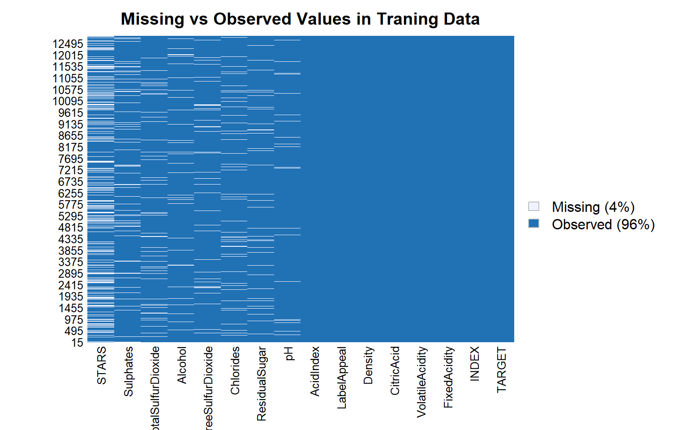

|  | **Non_NAs** | **NAs** | **NA_Percent** |
| --- | --- | --- | --- |
| TARGET | 12795 | 0 | 0.0000000 |
| INDEX | 12795 | 0 | 0.0000000 |
| FixedAcidity | 12795 | 0 | 0.0000000 |
| VolatileAcidity | 12795 | 0 | 0.0000000 |
| CitricAcid | 12795 | 0 | 0.0000000 |
| ResidualSugar | 12179 | 616 | 0.0481438 |
| Chlorides | 12157 | 638 | 0.0498632 |
| FreeSulfurDioxide | 12148 | 647 | 0.0505666 |
| TotalSulfurDioxide | 12113 | 682 | 0.0533021 |
| Density | 12795 | 0 | 0.0000000 |
| pH | 12400 | 395 | 0.0308714 |
| Sulphates | 11585 | 1210 | 0.0945682 |
| Alcohol | 12142 | 653 | 0.0510356 |
| LabelAppeal | 12795 | 0 | 0.0000000 |
| AcidIndex | 12795 | 0 | 0.0000000 |
| STARS | 9436 | 3359 | 0.2625244 |

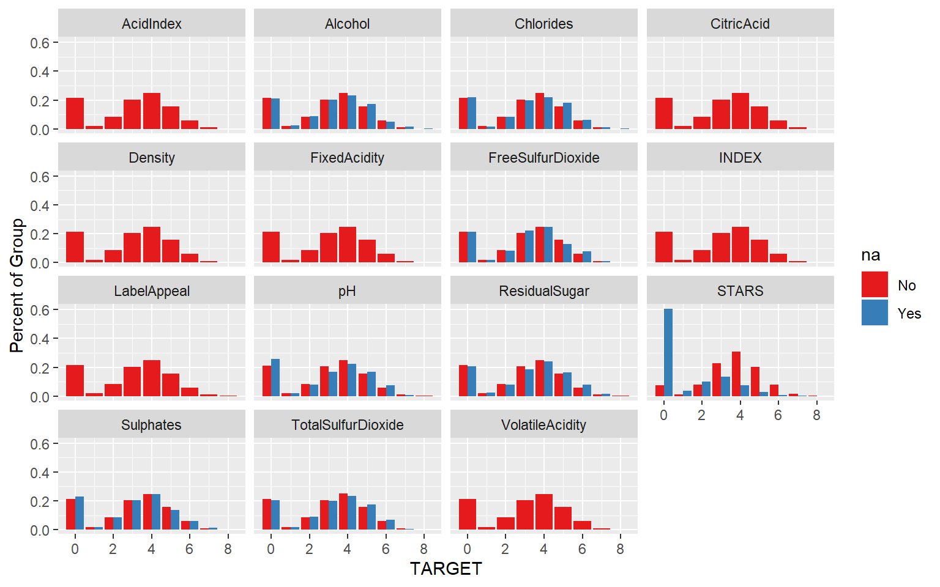Below is the summary of the datasets and some inference of it.

1. It seems there are Null values in the predictor variables but none ine response variables.
2. Each variables are in different scale.

### Data Statistics Summary

A binary logistic regression model is built using the training set, therefore the training set is used for the following data exploration.

The data types in the raw dataset are all ‘doubles’, however the counter INDEX and the response variable targetare categorical.

The statistics of all variables are list below:

## TARGET FixedAcidity VolatileAcidity CitricAcid

## Min. :0.000 Min. :-18.100 Min. :-2.7900 Min. :-3.2400

## 1st Qu.:2.000 1st Qu.: 5.200 1st Qu.: 0.1300 1st Qu.: 0.0300

## Median :3.000 Median : 6.900 Median : 0.2800 Median : 0.3100

## Mean :3.029 Mean : 7.076 Mean : 0.3241 Mean : 0.3084

## 3rd Qu.:4.000 3rd Qu.: 9.500 3rd Qu.: 0.6400 3rd Qu.: 0.5800

## Max. :8.000 Max. : 34.400 Max. : 3.6800 Max. : 3.8600

##

## ResidualSugar Chlorides FreeSulfurDioxide TotalSulfurDioxide

## Min. :-127.800 Min. :-1.1710 Min. :-555.00 Min. :-823.0

## 1st Qu.: -2.000 1st Qu.:-0.0310 1st Qu.: 0.00 1st Qu.: 27.0

## Median : 3.900 Median : 0.0460 Median : 30.00 Median : 123.0

## Mean : 5.419 Mean : 0.0548 Mean : 30.85 Mean : 120.7

## 3rd Qu.: 15.900 3rd Qu.: 0.1530 3rd Qu.: 70.00 3rd Qu.: 208.0

## Max. : 141.150 Max. : 1.3510 Max. : 623.00 Max. :1057.0

## NA's :616 NA's :638 NA's :647 NA's :682

## Density pH Sulphates Alcohol

## Min. :0.8881 Min. :0.480 Min. :-3.1300 Min. :-4.70

## 1st Qu.:0.9877 1st Qu.:2.960 1st Qu.: 0.2800 1st Qu.: 9.00

## Median :0.9945 Median :3.200 Median : 0.5000 Median :10.40

## Mean :0.9942 Mean :3.208 Mean : 0.5271 Mean :10.49

## 3rd Qu.:1.0005 3rd Qu.:3.470 3rd Qu.: 0.8600 3rd Qu.:12.40

## Max. :1.0992 Max. :6.130 Max. : 4.2400 Max. :26.50

## NA's :395 NA's :1210 NA's :653

## LabelAppeal AcidIndex STARS

## Min. :-2.000000 Min. : 4.000 Min. :1.000

## 1st Qu.:-1.000000 1st Qu.: 7.000 1st Qu.:1.000

## Median : 0.000000 Median : 8.000 Median :2.000

## Mean :-0.009066 Mean : 7.773 Mean :2.042

## 3rd Qu.: 1.000000 3rd Qu.: 8.000 3rd Qu.:3.000

## Max. : 2.000000 Max. :17.000 Max. :4.000

## NA's :3359

The statistics of TARGET Variable.

* **TARGET:** Number of Cases Purchased as Actual
* ## Min. 1st Qu. Median Mean 3rd Qu. Max. StdD Skew Kurt
* ## 0.00 2.00 3.00 3.03 4.00 8.00 1.93 -0.33 -0.88

**Data** **Exploration**

The first step we did was to import the data from GitHub, remove the index and look at the structure of the data.

## Outliers

## 

The box plot below shows that outliners exist in variables FixedAcidity, VolatileAcidity, CitricAcid,ResidualSugar, Chlorides, FreeSulfurDioxide, TotalSulfurDioxide, Density, pH, Sulphates, Alcohol,LabelAppeal andAcidIndex. We use scaled training set to draw the box plot to show the corresponding outliers by ratio.

## Histogram of attributes

Lets analyze the attributes of the dataset individually in terms of Histogram,, QQ Plot and BoxPlot in comparison to TARGET

* **FixedAcidity:** This variable tells us about the FixedAcidity of wine.

## 

* **VolatileAcidity:** This variable tells us about the VolatileAcidity content of Wine.

## 

* **CitricAcid:** This variable tells us about the Citric Acid Content of wine.

## 

* **ResidualSugar:** This variable tells us about the ResidualSugar of wine.

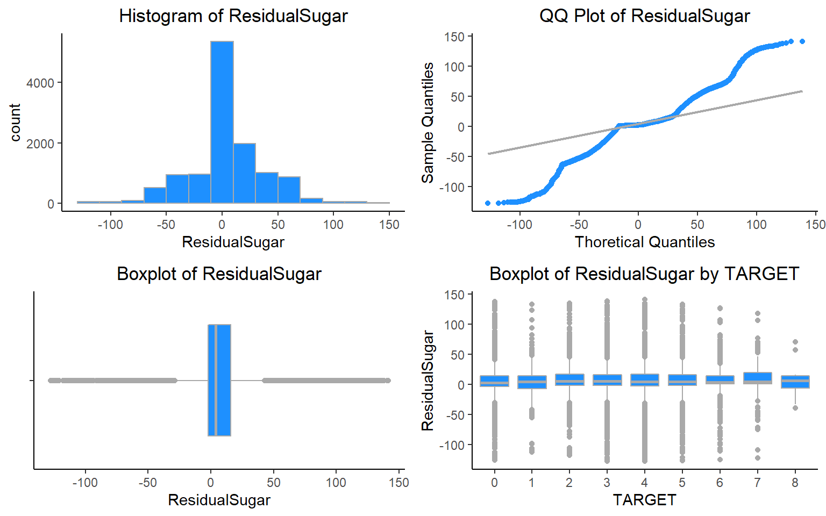

* **Chlorides:** This variable tells us about the Chloride content of wine.

## 

* **FreeSulfurDioxide** : This variable tells us about the Sulfur Dioxide content of wine.

## 

* **TotalSulfurDioxide** : This variable tells us about the Total Sulfur Dioxide of Wine.

## 

* **Density:** This variable tells us about the Density of wine.

## 

* **Sulphates:** This variable tells us about the Sulphates content of wine.

## 

* **Alcohol:** This variable tells us about the Alcohol content.

## 

* **LabelAppeal:** Marketing Score indicating the appeal of label design for consumers. High numbers suggest customers like the label design. Negative numbers suggest customers don’t like the design. Many consumers purchase based on the visual appeal of the wine label design. Higher numbers suggest better sales.

## 

* **AcidIndex:** Proprietary method of testing total acidity of wine by using a weighted average.

## 

AcidIndex seems to be skewed slightly. It also has a skew of 1.68. This is not enough to worry about.

* **STARS:** Wine rating by a team of experts. 4 Stars = Excellent, 1 Star = Poor. A high number of stars suggests high sales.

## 

## Density Plot

## 

The scaled histogram and density plots show that variables AcidIndex is right skewed; AcidIndex, STARS,LabelAppeal and TARGET have multimodal distribution; while most others seem to be normally distrbuted due to the bell curve they display.

## Label Scores

## Univariate Analysis

### Response Variable

## 

## Correlation Plot

We implement a correlation matrix to better understand the correlation between variables in the dataset.

## 

## 

## The correlation matrix below shows that the response variable TARGET has strong positive relationship (>=0.6) with variables FixedAcidity,CitricAcid,ResidualSugar,Density,Alcohol.

## 

## Scatter plots against TARGET:

## 

## There don’t seem to be any crazy patterns here. It mostly looks linear which is a good sign for us. STARS and LableAppleal look like they have the greatest correlation.

## 

## Consolidated Data Dictionary

As a summary of the data exploration process, a data dictionary is created below:

| **Variable** | **Missing_Value** | **Mean** | **Median** | **Max** | **Min** | **SD** | **Correlation_vs_Response** |
| --- | --- | --- | --- | --- | --- | --- | --- |
| TARGET | No | NA | NA | NA | NA | NA | 1.00 |
| INDEX | No | NA | NA | NA | NA | NA | 0.00 |
| FixedAcidity | No | 7.08 | 6.90 | 34.40 | -18.10 | 6.32 | -0.05 |
| VolatileAcidity | No | 0.32 | 0.28 | 3.68 | -2.79 | 0.78 | -0.09 |
| CitricAcid | No | 0.31 | 0.31 | 3.86 | -3.24 | 0.86 | 0.01 |
| ResidualSugar | No | NA | NA | NA | NA | NaN | NA |
| Chlorides | No | NA | NA | NA | NA | NaN | NA |
| FreeSulfurDioxide | No | NA | NA | NA | NA | NaN | NA |
| TotalSulfurDioxide | No | NA | NA | NA | NA | NaN | NA |
| Density | No | 0.99 | 0.99 | 1.10 | 0.89 | 0.03 | -0.04 |
| pH | No | NA | NA | NA | NA | NaN | NA |
| Sulphates | No | NA | NA | NA | NA | NaN | NA |
| Alcohol | No | NA | NA | NA | NA | NaN | NA |
| LabelAppeal | No | -0.01 | 0.00 | 2.00 | -2.00 | 0.89 | 0.36 |
| AcidIndex | No | 7.77 | 8.00 | 17.00 | 4.00 | 1.32 | -0.25 |
| STARS | No | NA | NA | NA | NA | NaN | NA |

# DATA PREPARATION

Lets first split the data into training and test.

MICE (Multivariate Imputation by Chained Equations) package helps in inspecting, imputing, diagonise, analyze, pool the result, and generate simulated incomplete data

Given the low correlation between AcidIndex and TARGET it might not make a huge difference, however, we will log transform it to test.

# BUILD MODELS

## Model I: Poisson Model

### Model 1: Poisson Model without imputations

##

## Call:

## glm(formula = TARGET ~ ., family = poisson, data = wine_train1)

##

## Deviance Residuals:

## Min 1Q Median 3Q Max

## -3.2128 -0.2757 0.0647 0.3766 1.6981

##

## Coefficients:

## Estimate Std. Error z value Pr(>|z|)

## (Intercept) 1.608e+00 2.796e-01 5.750 8.90e-09 ***

## FixedAcidity 6.705e-04 1.177e-03 0.570 0.56901

## VolatileAcidity -2.750e-02 9.283e-03 -2.963 0.00305 **

## CitricAcid -3.835e-03 8.519e-03 -0.450 0.65259

## ResidualSugar 1.828e-05 2.152e-04 0.085 0.93232

## Chlorides -3.764e-02 2.314e-02 -1.627 0.10377

## FreeSulfurDioxide 5.671e-05 4.892e-05 1.159 0.24630

## TotalSulfurDioxide 2.230e-05 3.177e-05 0.702 0.48274

## Density -4.025e-01 2.749e-01 -1.464 0.14326

## pH 2.307e-04 1.085e-02 0.021 0.98303

## Sulphates -5.984e-03 7.973e-03 -0.751 0.45293

## Alcohol 3.262e-03 2.004e-03 1.628 0.10360

## LabelAppeal 1.730e-01 8.858e-03 19.530 < 2e-16 ***

## AcidIndex -4.967e-02 6.666e-03 -7.451 9.28e-14 ***

## STARS 1.929e-01 8.328e-03 23.160 < 2e-16 ***

## ---

## Signif. codes: 0 '***' 0.001 '**' 0.01 '*' 0.05 '.' 0.1 ' ' 1

##

## (Dispersion parameter for poisson family taken to be 1)

##

## Null deviance: 4720.5 on 5143 degrees of freedom

## Residual deviance: 3242.8 on 5129 degrees of freedom

## (5093 observations deleted due to missingness)

## AIC: 18545

##

## Number of Fisher Scoring iterations: 5

## 

## 

## 

## 

## 

### Model 2: Poisson Model without imputations and only significant variables

##

## Call:

## glm(formula = TARGET ~ . - FixedAcidity - CitricAcid - ResidualSugar -

## Chlorides - FreeSulfurDioxide - TotalSulfurDioxide - Density -

## pH - Sulphates - Alcohol, family = poisson, data = wine_train1)

##

## Deviance Residuals:

## Min 1Q Median 3Q Max

## -3.1898 -0.2777 0.0622 0.3764 1.6086

##

## Coefficients:

## Estimate Std. Error z value Pr(>|z|)

## (Intercept) 1.251442 0.054724 22.868 < 2e-16 ***

## VolatileAcidity -0.027581 0.009278 -2.973 0.00295 **

## LabelAppeal 0.173177 0.008853 19.562 < 2e-16 ***

## AcidIndex -0.050616 0.006553 -7.724 1.13e-14 ***

## STARS 0.194208 0.008292 23.421 < 2e-16 ***

## ---

## Signif. codes: 0 '***' 0.001 '**' 0.01 '*' 0.05 '.' 0.1 ' ' 1

##

## (Dispersion parameter for poisson family taken to be 1)

##

## Null deviance: 4720.5 on 5143 degrees of freedom

## Residual deviance: 3253.1 on 5139 degrees of freedom

## (5093 observations deleted due to missingness)

## AIC: 18535

##

## Number of Fisher Scoring iterations: 5

## 

## 

## 

## 

### Model 3: Poisson Model with imputations

##

## Call:

## glm(formula = TARGET ~ ., family = poisson, data = wine_train2)

##

## Deviance Residuals:

## Min 1Q Median 3Q Max

## -3.1630 -0.6739 0.1305 0.6337 2.4320

##

## Coefficients:

## Estimate Std. Error z value Pr(>|z|)

## (Intercept) 2.337e+00 2.281e-01 10.242 < 2e-16 ***

## FixedAcidity 2.250e-04 9.190e-04 0.245 0.806610

## VolatileAcidity -4.313e-02 7.286e-03 -5.919 3.23e-09 ***

## CitricAcid 8.534e-03 6.573e-03 1.298 0.194168

## ResidualSugar 1.271e-04 1.675e-04 0.759 0.448033

## Chlorides -6.572e-02 1.790e-02 -3.673 0.000240 ***

## FreeSulfurDioxide 1.336e-04 3.804e-05 3.512 0.000444 ***

## TotalSulfurDioxide 9.235e-05 2.460e-05 3.754 0.000174 ***

## Density -3.404e-01 2.144e-01 -1.588 0.112379

## pH -1.962e-02 8.417e-03 -2.331 0.019744 *

## Sulphates -1.569e-02 6.157e-03 -2.549 0.010805 *

## Alcohol 2.951e-03 1.554e-03 1.898 0.057632 .

## LabelAppeal 1.409e-01 6.798e-03 20.724 < 2e-16 ***

## AcidIndex -7.709e-01 3.998e-02 -19.280 < 2e-16 ***

## STARS 3.407e-01 6.270e-03 54.337 < 2e-16 ***

## ---

## Signif. codes: 0 '***' 0.001 '**' 0.01 '*' 0.05 '.' 0.1 ' ' 1

##

## (Dispersion parameter for poisson family taken to be 1)

##

## Null deviance: 18291 on 10236 degrees of freedom

## Residual deviance: 12829 on 10222 degrees of freedom

## AIC: 38417

##

## Number of Fisher Scoring iterations: 5

## 

## 

## 

## 

### Model 4: Poisson Model with imputations and only significant variables

##

## Call:

## glm(formula = TARGET ~ . - FixedAcidity - CitricAcid - ResidualSugar -

## Density - Alcohol, family = poisson, data = wine_train2)

##

## Deviance Residuals:

## Min 1Q Median 3Q Max

## -3.1469 -0.6828 0.1295 0.6379 2.4054

##

## Coefficients:

## Estimate Std. Error z value Pr(>|z|)

## (Intercept) 2.038e+00 8.840e-02 23.052 < 2e-16 ***

## VolatileAcidity -4.348e-02 7.284e-03 -5.969 2.39e-09 ***

## Chlorides -6.725e-02 1.789e-02 -3.760 0.000170 ***

## FreeSulfurDioxide 1.316e-04 3.801e-05 3.461 0.000537 ***

## TotalSulfurDioxide 9.150e-05 2.458e-05 3.723 0.000197 ***

## pH -1.991e-02 8.415e-03 -2.366 0.018003 *

## Sulphates -1.563e-02 6.153e-03 -2.540 0.011086 *

## LabelAppeal 1.409e-01 6.798e-03 20.727 < 2e-16 ***

## AcidIndex -7.729e-01 3.936e-02 -19.636 < 2e-16 ***

## STARS 3.417e-01 6.255e-03 54.634 < 2e-16 ***

## ---

## Signif. codes: 0 '***' 0.001 '**' 0.01 '*' 0.05 '.' 0.1 ' ' 1

##

## (Dispersion parameter for poisson family taken to be 1)

##

## Null deviance: 18291 on 10236 degrees of freedom

## Residual deviance: 12837 on 10227 degrees of freedom

## AIC: 38415

##

## Number of Fisher Scoring iterations: 5

## 

## 

## 

## 

## Model II: Negative Binomial

### Model 5 : Negative Binomial without imputations

##

## Call:

## glm.nb(formula = TARGET ~ ., data = wine_train1, init.theta = 138898.9107,

## link = log)

##

## Deviance Residuals:

## Min 1Q Median 3Q Max

## -3.2127 -0.2757 0.0647 0.3766 1.6981

##

## Coefficients:

## Estimate Std. Error z value Pr(>|z|)

## (Intercept) 1.608e+00 2.796e-01 5.750 8.91e-09 ***

## FixedAcidity 6.705e-04 1.177e-03 0.570 0.56900

## VolatileAcidity -2.750e-02 9.283e-03 -2.963 0.00305 **

## CitricAcid -3.835e-03 8.519e-03 -0.450 0.65259

## ResidualSugar 1.828e-05 2.152e-04 0.085 0.93231

## Chlorides -3.764e-02 2.314e-02 -1.627 0.10378

## FreeSulfurDioxide 5.671e-05 4.892e-05 1.159 0.24630

## TotalSulfurDioxide 2.230e-05 3.177e-05 0.702 0.48275

## Density -4.025e-01 2.750e-01 -1.464 0.14326

## pH 2.307e-04 1.085e-02 0.021 0.98303

## Sulphates -5.984e-03 7.973e-03 -0.751 0.45293

## Alcohol 3.262e-03 2.004e-03 1.628 0.10360

## LabelAppeal 1.730e-01 8.858e-03 19.529 < 2e-16 ***

## AcidIndex -4.967e-02 6.666e-03 -7.451 9.28e-14 ***

## STARS 1.929e-01 8.328e-03 23.160 < 2e-16 ***

## ---

## Signif. codes: 0 '***' 0.001 '**' 0.01 '*' 0.05 '.' 0.1 ' ' 1

##

## (Dispersion parameter for Negative Binomial(138898.9) family taken to be 1)

##

## Null deviance: 4720.4 on 5143 degrees of freedom

## Residual deviance: 3242.7 on 5129 degrees of freedom

## (5093 observations deleted due to missingness)

## AIC: 18547

##

## Number of Fisher Scoring iterations: 1

##

##

## Theta: 138899

## Std. Err.: 259921

## Warning while fitting theta: iteration limit reached

##

## 2 x log-likelihood: -18515.07

## 

## 

## 

## 

### Model 6 : Negative Binomial without imputations and only significant variables

##

## Call:

## glm.nb(formula = TARGET ~ . - FixedAcidity - CitricAcid - ResidualSugar -

## Chlorides - FreeSulfurDioxide - TotalSulfurDioxide - Density -

## pH - Sulphates - Alcohol, data = wine_train1, init.theta = 138402.5261,

## link = log)

##

## Deviance Residuals:

## Min 1Q Median 3Q Max

## -3.1898 -0.2777 0.0622 0.3764 1.6086

##

## Coefficients:

## Estimate Std. Error z value Pr(>|z|)

## (Intercept) 1.251443 0.054725 22.868 < 2e-16 ***

## VolatileAcidity -0.027581 0.009279 -2.973 0.00295 **

## LabelAppeal 0.173177 0.008853 19.562 < 2e-16 ***

## AcidIndex -0.050616 0.006553 -7.724 1.13e-14 ***

## STARS 0.194209 0.008292 23.421 < 2e-16 ***

## ---

## Signif. codes: 0 '***' 0.001 '**' 0.01 '*' 0.05 '.' 0.1 ' ' 1

##

## (Dispersion parameter for Negative Binomial(138402.5) family taken to be 1)

##

## Null deviance: 4720.4 on 5143 degrees of freedom

## Residual deviance: 3253.0 on 5139 degrees of freedom

## (5093 observations deleted due to missingness)

## AIC: 18537

##

## Number of Fisher Scoring iterations: 1

##

##

## Theta: 138403

## Std. Err.: 258834

## Warning while fitting theta: iteration limit reached

##

## 2 x log-likelihood: -18525.37

## 

## 

## 

## 

### Model 7 : Negative Binomial with imputations

##

## Call:

## glm.nb(formula = TARGET ~ ., data = wine_train2, init.theta = 49078.50992,

## link = log)

##

## Deviance Residuals:

## Min 1Q Median 3Q Max

## -3.1629 -0.6739 0.1305 0.6337 2.4320

##

## Coefficients:

## Estimate Std. Error z value Pr(>|z|)

## (Intercept) 2.337e+00 2.281e-01 10.242 < 2e-16 ***

## FixedAcidity 2.250e-04 9.190e-04 0.245 0.806608

## VolatileAcidity -4.313e-02 7.286e-03 -5.919 3.23e-09 ***

## CitricAcid 8.534e-03 6.573e-03 1.298 0.194177

## ResidualSugar 1.271e-04 1.675e-04 0.759 0.448021

## Chlorides -6.573e-02 1.790e-02 -3.673 0.000240 ***

## FreeSulfurDioxide 1.336e-04 3.804e-05 3.512 0.000444 ***

## TotalSulfurDioxide 9.235e-05 2.460e-05 3.754 0.000174 ***

## Density -3.404e-01 2.144e-01 -1.588 0.112389

## pH -1.962e-02 8.418e-03 -2.331 0.019745 *

## Sulphates -1.569e-02 6.157e-03 -2.549 0.010806 *

## Alcohol 2.951e-03 1.554e-03 1.898 0.057642 .

## LabelAppeal 1.409e-01 6.798e-03 20.723 < 2e-16 ***

## AcidIndex -7.709e-01 3.999e-02 -19.279 < 2e-16 ***

## STARS 3.407e-01 6.270e-03 54.335 < 2e-16 ***

## ---

## Signif. codes: 0 '***' 0.001 '**' 0.01 '*' 0.05 '.' 0.1 ' ' 1

##

## (Dispersion parameter for Negative Binomial(49078.51) family taken to be 1)

##

## Null deviance: 18290 on 10236 degrees of freedom

## Residual deviance: 12828 on 10222 degrees of freedom

## AIC: 38419

##

## Number of Fisher Scoring iterations: 1

##

##

## Theta: 49079

## Std. Err.: 63619

## Warning while fitting theta: iteration limit reached

##

## 2 x log-likelihood: -38387.04

## 

## 

## 

## 

### Model 8 : Negative Binomial with imputations and only significant variables

##

## Call:

## glm.nb(formula = TARGET ~ . - FixedAcidity - CitricAcid - ResidualSugar -

## Density - Alcohol, data = wine_train2, init.theta = 48992.35936,

## link = log)

##

## Deviance Residuals:

## Min 1Q Median 3Q Max

## -3.1469 -0.6828 0.1295 0.6379 2.4053

##

## Coefficients:

## Estimate Std. Error z value Pr(>|z|)

## (Intercept) 2.038e+00 8.840e-02 23.052 < 2e-16 ***

## VolatileAcidity -4.348e-02 7.284e-03 -5.969 2.39e-09 ***

## Chlorides -6.726e-02 1.789e-02 -3.760 0.000170 ***

## FreeSulfurDioxide 1.316e-04 3.801e-05 3.461 0.000537 ***

## TotalSulfurDioxide 9.150e-05 2.458e-05 3.723 0.000197 ***

## pH -1.991e-02 8.415e-03 -2.366 0.018004 *

## Sulphates -1.563e-02 6.153e-03 -2.540 0.011087 *

## LabelAppeal 1.409e-01 6.798e-03 20.726 < 2e-16 ***

## AcidIndex -7.730e-01 3.936e-02 -19.636 < 2e-16 ***

## STARS 3.417e-01 6.255e-03 54.632 < 2e-16 ***

## ---

## Signif. codes: 0 '***' 0.001 '**' 0.01 '*' 0.05 '.' 0.1 ' ' 1

##

## (Dispersion parameter for Negative Binomial(48992.36) family taken to be 1)

##

## Null deviance: 18290 on 10236 degrees of freedom

## Residual deviance: 12837 on 10227 degrees of freedom

## AIC: 38418

##

## Number of Fisher Scoring iterations: 1

##

##

## Theta: 48992

## Std. Err.: 63531

## Warning while fitting theta: iteration limit reached

##

## 2 x log-likelihood: -38395.56

## 

## 

## 

## 

## Model III: Linear Model

### Model 9 : Linear Model with imputations

Using Linear Regression Model on imputed training data.

##

## Call:

## lm(formula = TARGET ~ ., data = wine_train2)

##

## Residuals:

## Min 1Q Median 3Q Max

## -4.7147 -1.0144 0.1737 1.0276 4.3109

##

## Coefficients:

## Estimate Std. Error t value Pr(>|t|)

## (Intercept) 5.968e+00 5.567e-01 10.719 < 2e-16 ***

## FixedAcidity 1.297e-03 2.253e-03 0.576 0.564897

## VolatileAcidity -1.269e-01 1.791e-02 -7.085 1.48e-12 ***

## CitricAcid 2.625e-02 1.629e-02 1.611 0.107133

## ResidualSugar 4.231e-04 4.132e-04 1.024 0.305939

## Chlorides -2.023e-01 4.391e-02 -4.606 4.15e-06 ***

## FreeSulfurDioxide 3.635e-04 9.387e-05 3.873 0.000108 ***

## TotalSulfurDioxide 2.432e-04 6.023e-05 4.038 5.42e-05 ***

## Density -8.659e-01 5.260e-01 -1.646 0.099740 .

## pH -4.730e-02 2.072e-02 -2.283 0.022424 *

## Sulphates -4.212e-02 1.512e-02 -2.786 0.005346 **

## Alcohol 1.251e-02 3.807e-03 3.285 0.001025 **

## LabelAppeal 4.311e-01 1.646e-02 26.191 < 2e-16 ***

## AcidIndex -2.068e+00 9.237e-02 -22.392 < 2e-16 ***

## STARS 1.167e+00 1.671e-02 69.805 < 2e-16 ***

## ---

## Signif. codes: 0 '***' 0.001 '**' 0.01 '*' 0.05 '.' 0.1 ' ' 1

##

## Residual standard error: 1.416 on 10222 degrees of freedom

## Multiple R-squared: 0.4605, Adjusted R-squared: 0.4598

## F-statistic: 623.3 on 14 and 10222 DF, p-value: < 2.2e-16

## 

## 

## 

## 

### Model 10 : Linear Model with imputations and only significant variables.

As we know the significant variables are FixedAcidity, CitricAcid and ResidualSugar, so using the same in the Linear Regression Model and applying the same of imputed training data.

##

## Call:

## lm(formula = TARGET ~ . - FixedAcidity - CitricAcid - ResidualSugar,

## data = wine_train2)

##

## Residuals:

## Min 1Q Median 3Q Max

## -4.7242 -1.0131 0.1728 1.0331 4.3050

##

## Coefficients:

## Estimate Std. Error t value Pr(>|t|)

## (Intercept) 5.951e+00 5.566e-01 10.691 < 2e-16 ***

## VolatileAcidity -1.278e-01 1.791e-02 -7.138 1.01e-12 ***

## Chlorides -2.032e-01 4.391e-02 -4.627 3.75e-06 ***

## FreeSulfurDioxide 3.660e-04 9.386e-05 3.899 9.71e-05 ***

## TotalSulfurDioxide 2.454e-04 6.021e-05 4.075 4.63e-05 ***

## Density -8.712e-01 5.260e-01 -1.656 0.09768 .

## pH -4.728e-02 2.071e-02 -2.282 0.02249 *

## Sulphates -4.236e-02 1.511e-02 -2.803 0.00507 **

## Alcohol 1.249e-02 3.807e-03 3.281 0.00104 **

## LabelAppeal 4.310e-01 1.646e-02 26.186 < 2e-16 ***

## AcidIndex -2.048e+00 9.074e-02 -22.572 < 2e-16 ***

## STARS 1.167e+00 1.671e-02 69.833 < 2e-16 ***

## ---

## Signif. codes: 0 '***' 0.001 '**' 0.01 '*' 0.05 '.' 0.1 ' ' 1

##

## Residual standard error: 1.416 on 10225 degrees of freedom

## Multiple R-squared: 0.4603, Adjusted R-squared: 0.4598

## F-statistic: 792.9 on 11 and 10225 DF, p-value: < 2.2e-16

## 

## 

## 

## 

## Model 11 : Ordinal Logistic Regression

This regression uses ordered factors. I would expect this to be one of the top performers.

## Call:

## polr(formula = TARGET ~ ., data = polrDF, Hess = TRUE)

##

## Coefficients:

## Value Std. Error t value

## FixedAcidity 0.0021819 0.0029055 0.7510

## VolatileAcidity -0.1555960 0.0232760 -6.6848

## CitricAcid 0.0289713 0.0211212 1.3717

## ResidualSugar 0.0003196 0.0005320 0.6008

## Chlorides -0.2627487 0.0566657 -4.6368

## FreeSulfurDioxide 0.0004607 0.0001216 3.7875

## TotalSulfurDioxide 0.0002716 0.0000783 3.4686

## Density -1.2981402 0.1490930 -8.7069

## pH -0.0314095 0.0268078 -1.1717

## Sulphates -0.0339150 0.0196712 -1.7241

## Alcohol 0.0269097 0.0048969 5.4953

## LabelAppeal 0.8256163 0.0237699 34.7337

## AcidIndex -2.6646249 0.1250905 -21.3016

## STARS 1.4684471 0.0256683 57.2086

##

## Intercepts:

## Value Std. Error t value

## 0|1 -5.9211 0.1357 -43.6446

## 1|2 -5.7842 0.1355 -42.6743

## 2|3 -5.1811 0.1351 -38.3486

## 3|4 -3.8133 0.1350 -28.2556

## 4|5 -1.9656 0.1372 -14.3273

## 5|6 0.0034 0.1437 0.0237

## 6|7 2.2069 0.1675 13.1788

## 7|8 4.5480 0.3034 14.9895

##

## Residual Deviance: 30016.23

## AIC: 30060.23

## Model 12 : Zero inflation

Zero inflation understands that some Poisson distrobutions are dominated by many zeros. As such it corrects for this. This is one of the most promissing ones because as we saw in our data exploration, there were more zeros, and then normally distributed data after that.

##

## Call:

## zeroinfl(formula = TARGET ~ . | STARS, data = wine_train2, dist = "negbin")

##

## Pearson residuals:

## Min 1Q Median 3Q Max

## -2.09180 -0.49650 0.07134 0.48208 2.08565

##

## Count model coefficients (negbin with log link):

## Estimate Std. Error z value Pr(>|z|)

## (Intercept) 1.824e+00 2.385e-01 7.648 2.04e-14 ***

## FixedAcidity 4.523e-04 9.473e-04 0.477 0.633017

## VolatileAcidity -1.936e-02 7.560e-03 -2.561 0.010429 *

## CitricAcid 2.116e-03 6.718e-03 0.315 0.752830

## ResidualSugar -6.323e-05 1.722e-04 -0.367 0.713427

## Chlorides -3.245e-02 1.851e-02 -1.754 0.079503 .

## FreeSulfurDioxide 4.932e-05 3.854e-05 1.280 0.200613

## TotalSulfurDioxide 4.760e-06 2.460e-05 0.194 0.846535

## Density -2.990e-01 2.224e-01 -1.344 0.178840

## pH -1.910e-03 8.749e-03 -0.218 0.827223

## Sulphates -4.586e-03 6.391e-03 -0.718 0.473029

## Alcohol 5.950e-03 1.591e-03 3.741 0.000184 ***

## LabelAppeal 2.240e-01 7.112e-03 31.491 < 2e-16 ***

## AcidIndex -2.682e-01 4.492e-02 -5.971 2.36e-09 ***

## STARS 1.227e-01 6.997e-03 17.531 < 2e-16 ***

## Log(theta) 1.860e+01 2.758e+00 6.742 1.56e-11 ***

##

## Zero-inflation model coefficients (binomial with logit link):

## Estimate Std. Error z value Pr(>|z|)

## (Intercept) 2.31678 0.11092 20.89 <2e-16 ***

## STARS -2.66899 0.09689 -27.55 <2e-16 ***

## ---

## Signif. codes: 0 '***' 0.001 '**' 0.01 '*' 0.05 '.' 0.1 ' ' 1

##

## Theta = 119421399.3444

## Number of iterations in BFGS optimization: 22

## Log-likelihood: -1.725e+04 on 18 Df

## 

## 

# MODEL SELECTION

## Compare Models by MSE/AIC

| **MSE** | **AIC** |  |
| --- | --- | --- |
| Model1 | 6.929787 | 6.926722 |
| Model2 | 6.849005 | 6.849920 |
| Model3 | 6.929788 | 6.926723 |
| Model4 | 6.849001 | 6.849916 |
| Model5 | 2.002207 | 2.002977 |
| Model6 | NA | 1.988813 |
| Model7 | 18544.983192 | 18535.285631 |
| Model8 | 38416.867732 | 38415.386508 |
| Model9 | 18547.067808 | 18537.370350 |
| Model10 | 38419.044066 | 38417.562708 |
| Model11 | 6.929787 | 6.926722 |
| Model12 | 6.849005 | 6.849920 |

**Compare Models by Loss**

Now lets see the output of the Models using test data

We will use the squared loss to validate the model. We will use the squared difference to select a model (MSE) from predictions on the training sets. (Lower numbers are better.)

|  | **Loss:**  <dbl> |
| --- | --- |
| Model1 | 5.471932 |
| Model2 | 5.456474 |
| Model3 | 6.827070 |
| Model4 | 6.828240 |
| Model5 | 5.471926 |
| Model6 | 5.456468 |
| Model7 | 6.827066 |
| Model8 | 6.828236 |
| Model9 | 2.034647 |
| Model10 | 2.034185 |

Next

Following deductions can be made as per above values:

* A regular Poisson regression does not perform very well.
* The same can be said for the Negative Binomial.
* The linear model actually performs very well.
* Very surprisinly, Ordinal Logistic Regression does not work as well as the linear model.

Because we are not interested in gaining insight into the underlying causes of wine selection, we will use the squared loss. This will tell us how accurate our model is without caring about confidence intervals etc.

Based on this metric, Zero Poission Inflation is the most accurate.

From the above models, Model12 - Zero Poission Inflations has least loss as it uses less variables and is parsimonious. Also the R2 looks fine. The squared loss is also fine.

* In terms of MSE and AIC, Model 5 is best followed by Model 4 and tied Model 2 and Model 12.
* In terms of Loss, Model 12 is best followed closely by Model 9 and Model 10.

Overall, we choose Zero Poission Inflation due to following : - least loss - good MSE score - good AIC score

## 6.3 Prediction on Evaluation Data

We will use the same method to impute and use log transformation for AcidIndex.

|  | **TARGET** | **FixedAcidity** | **VolatileAcidity** | **CitricAcid** | **ResidualSugar** | **Chlorides** | **FreeSulfurDioxide** | **TotalSulfurDioxide** | **Density** | **pH** | **Sulphates** | **Alcohol** | **LabelAppeal** | **AcidIndex** | **STARS** |
| --- | --- | --- | --- | --- | --- | --- | --- | --- | --- | --- | --- | --- | --- | --- | --- |
| 1 | 3.01474113581073 | 5.4 | -0.86 | 0.27 | -10.7 | 0.092 | 23 | 398 | 0.98527 | 5.02 | 0.64 | 12.3 | -1 | 1.79175946922805 | 2 |
| 2 | 3.62186861554457 | 12.4 | 0.385 | -0.76 | -19.7 | 1.169 | -37 | 68 | 0.99048 | 3.37 | 1.09 | 16 | 0 | 1.79175946922805 | 2 |
| 3 | 1.73831939712905 | 7.2 | 1.75 | 0.17 | -33 | 0.065 | 9 | 76 | 1.04641 | 4.61 | 0.68 | 8.55 | 0 | 2.07944154167984 | 1 |
| 4 | 1.50697167978128 | 6.2 | 0.1 | 1.8 | 1 | -0.179 | 104 | 89 | 0.98877 | 3.2 | 2.11 | 12.3 | -1 | 2.07944154167984 | 1 |
| 5 | 1.67686808814121 | 11.4 | 0.21 | 0.28 | 1.2 | 0.038 | 70 | 53 | 1.02899 | 2.54 | -0.07 | 4.8 | 0 | 2.30258509299405 | 1 |
| 6 | 5.66375927126166 | 17.6 | 0.04 | -1.15 | 1.4 | 0.535 | -250 | 140 | 0.95028 | 3.06 | -0.02 | 11.4 | 1 | 2.07944154167984 | 4 |
| 7 | 3.38429159128796 | 15.5 | 0.53 | -0.53 | 4.6 | 1.263 | 10 | 17 | 1.0002 | 3.07 | 0.75 | 8.5 | 0 | 2.484906649788 | 3 |
| 8 | 5.17446610497721 | 15.9 | 1.19 | 1.14 | 31.9 | -0.299 | 115 | 381 | 1.03416 | 2.99 | 0.31 | 11.4 | 1 | 1.94591014905531 | 3 |
| 9 | 1.54080400134772 | 11.6 | 0.32 | 0.55 | -50.9 | 0.076 | 35 | 83 | 1.0002 | 3.32 | 2.18 | -0.5 | 0 | 2.484906649788 | 1 |
| 10 | 4.28161045753364 | 3.8 | 0.22 | 0.31 | -7.7 | 0.039 | 40 | 129 | 0.9061 | 4.72 | -0.64 | 10.9 | 0 | 1.94591014905531 | 3 |

Showing 1 to 10 of 3,335 entries

* **TARGET:** Number of Cases Purchased as Predicted
* ## Min. 1st Qu. Median Mean 3rd Qu. Max. StdD Skew Kurt
* ## 1.03 1.91 3.30 3.24 4.17 8.27 1.38 0.51 -0.32

**Make Predictions**

Predictions can be found in the following:

<https://github.com/Rajwantmishra/DATA621_CR4/blob/master/HW5/Evaluation_Full_Data.csv>

**Appendix**

<https://github.com/Rajwantmishra/DATA621_CR4/blob/master/HW5/HomeWork5.Rmd>

**Thank you**